08 game

DEADLINE 7 SEP

Popups

Click Multipliers

(x2 x4 x8 x16)

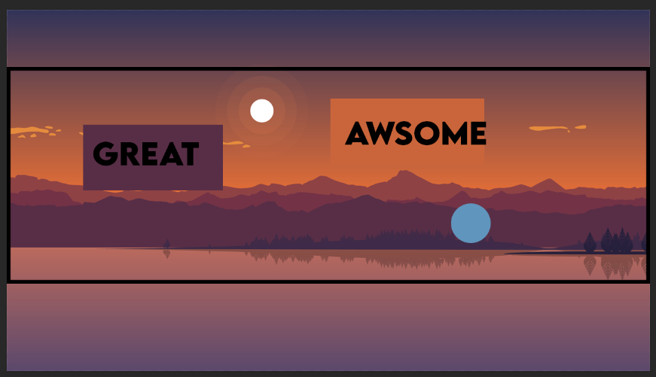

Levels

Liedjes kiezen

X font